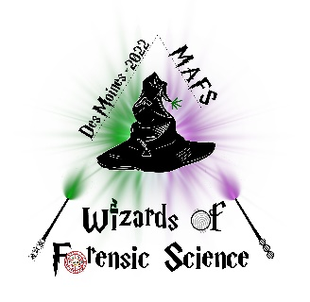
Midwestern Association of Forensic Scientists, Inc.
“A Professional, Scientific and Educational Organization”

MAFS 51st Annual Fall Meeting
September 11th through September 16th, 2022
Des Moines, Iowa

EXHIBITOR INFORMATION

The Exhibit Booth fee of $1,200 includes:
- All vendor spots in the same room! - First Come, First Served!
- Table, booth and two chairs
- Complimentary wi-fi internet for standard usage
- Standard electrical hookup (if needed)
- contact Exhibitor Chair for special electrical needs
- Up to 2 meeting registrations*
- Up to 2 luncheon tickets*
- Up to 2 Gala tickets*
- *additional registrations, luncheon tickets and/or gala tickets may be purchased separately

TENTATIVE SCHEDULE

Wednesday: Tours and Workshops
- not provided in exhibitor fee but may be purchased separately

Noon-4:00pm Exhibitor set up (Marriott Hotel)

5:00pm-8:00pm: Exhibitor Area open – Wine and Cheese Reception in Exhibitor Area

Thursday: Plenary Session, Business Meeting, Scientific Sessions (Marriott Hotel)

7:30am-Noon: Exhibitor Area Open – Morning Break in Exhibitor Area

12:00pm-1:00pm: Lunch

1:00pm-5:00pm: Exhibitor Area Open – Afternoon Break in Exhibitor Area

6:00pm-11:30pm: Gala (Marriott Hotel)

Friday: Scientific Sessions (Marriott Hotel)

8:30am-10:00am: Exhibitor Area open – Breakfast in Exhibitor Area

10:00am-Noon: Exhibitor tear down

Wireless internet will be available in the Exhibitor Area. A MAFS group rate is available for lodging accommodations; please call (515) 245-5500 for reservations starting March 1, 2022.

