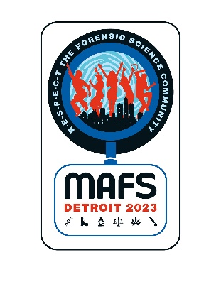
Midwestern Association of Forensic Scientists, Inc.
“A Professional, Scientific and Educational Organization”

MAFS 52nd Annual Fall Meeting
August 27th through September 1st, 2023
Detroit, Michigan

EXHIBITOR'S AGREEMENT

We wish to participate as an exhibitor at the 2023 Fall Meeting of the Midwestern Association of Forensic Scientists on August 27th – September 1st at the Fort Pontchartrain, a Wyndham Hotel in Detroit, Michigan.

We agree to pay an exhibitor's fee of $1,200, which will include one table, two chairs, and one signboard. Up to two registrations, two Thursday luncheon tickets, and two Thursday evening gala tickets will also be provided. Additional registrations may be purchased at a cost of a non-member registration – additional luncheon tickets and gala tickets are also available for purchase. The exhibitors are welcome to attend the scientific sessions and hospitality hours. Any and all other expenses shall be the responsibility of the exhibitor.

Exhibitors will set up their booths on Wednesday afternoon, August 29th, 2023. The exhibitor area will be open to the conference attendees Wednesday evening and all-day Thursday including breakfast with exhibitors, the Thursday morning break and Thursday afternoon break. There will not be a Friday morning event this year, so exhibitors are welcome to tear down either Thursday evening or Friday Morning. A tentative schedule of the exhibit hours can be found on the Exhibitor Information Page.

Company _____________________________________________
Address ________________________________________________________________
Phone Number ___________________________________
Email Address _________________________________________
Authorized Signature ____________________________________ Date ________________

Contact Person Information:
Name ________________________________________________
Phone Number ___________________________________
Email Address _________________________________________
# of Booth Representatives _____
# of Thursday luncheon tickets _____ # of Thursday night Gala Tickets ____
Rep Names (to appear on badges) _________________________________________
______________________________________________________________________

Electrical Requirements? □Y □N (specify) _______________________________________
Basic wireless Internet is included.

Booth space will be assigned on a first-come, first-served basis and only when full payment is made. Please make check payable to MAFS, Inc. Be advised that $100 of the exhibitor’s fee is non-refundable and no refunds will be made after July 28, 2023.

Contact: Brandy Cline, Exhibitor Chair Mail Checks to: Dana Greely
Indiana State Police Laboratory 6170 Locust St.
550 W. 16th Street, Suite C Commerce City, CO 80022
Indianapolis, IN 46202 (303) 463-7087
(317) 921-5378 mafsmeettreasurer@gmail.com
bcline@isp.in.gov

